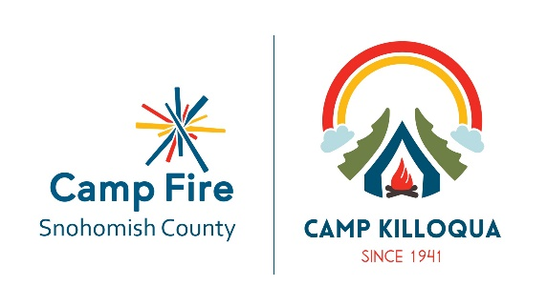
Club Camping at Camp Killoqua
General Camp Information:
- Club Camping is designed for Camp Fire Clubs who want to go camping to enjoy a quiet weekend away from the business of public campgrounds.
- Our cabins are simple – they have bunk beds with foam camp mattresses. Clubs are responsible for bringing their own bedding. Bathrooms have hand soap, paper towels, and toilet paper provided. Clubs must bring any other desired toiletries. Cabins with kitchens have a refrigerator, oven, sink, microwave, and counter space. Clubs must provide all utensils and cooking supplies.
- No smoking, alcoholic beverages, or drugs are allowed on site, as we are a youth centered organization.
- Boating is offered for several hours on Saturday and Sunday. The trading post is usually open on Sunday. All other activities are up to Clubs. Clubs can bring things like bikes (helmets required). We have a soccer field, trails for hiking and biking, a basketball court, human foosball, and gaga ball. Camp Staffed activities are subject to change. The camp host will contact you about two weeks prior to the weekend to confirm the schedule.
- Clubs are responsible for their own food while onsite. Some cabins have kitchens, others have fire rings nearby. Clubs are welcome to bring camping stoves, but must use them on picnic tables outside, not on cabin porches or inside cabins. Clubs will be assigned a fire ring upon check-in. We are within 15 minutes driving distance to many area restaurants (Stanwood, Smokey Point).
- Quiet hours are from 9:30pm to 7:00am.
- Archery and all built challenge elements (ropes, boards, and bouldering) are not to be used without staff supervision.
Friday night Clubs should plan to leave the unit lodges by 4:00pm on Saturday. Clubs may remain in camp after 4:00pm on Saturday but the unit lodges must be vacated by that time.
Saturday night clubs should plan to use lodges after 4:30pm.
Building information and descriptions
Bluebird (5 cabins available) and Whulje (4 cabins available): Sleeps 9 people, electric heat and lights. No kitchen in these cabins.
Aframe: Sleeps 25. Kitchen, 2 bathrooms, 17 beds upstairs in dormitory style arrangement, 8 beds downstairs with the kitchen, both bathrooms, and an open area. You can request tables and chairs for this cabin. Electric heat and lights, fireplace downstairs.
Cambium: Sleeps 30. Upstairs has two bathrooms, kitchen, small meeting area, and 4 bedrooms with 4 beds in each room. Downstairs has a bathroom, one bedroom with 4 beds, and a main room with 10 beds. Electric heat and lights upstairs, downstairs has electric heat in bathroom and bedroom. The main area is heated by woodstove.
CIT: Sleeps 12 in main room, 8 in side room. Electric lights in main room, no electricity in side room. Main room is heated by woodstove. Bathroom and kitchen is a short walk across the porch from both rooms. Both bathroom and kitchen have electric heat and lights. You can request a table for the kitchen.
Hill House: Sleeps 20. There are 2 bedrooms with 4 beds, and two bedrooms with 6 beds. Two bathrooms, kitchen and a large meeting area. Woodstove, electric lights and heat throughout.
Pioneer: Sleeps 6-20. This is a tree house unit. The tree houses are on poles and are open to the air. There are 3 and each has 5 beds. The main unit lodge sleeps 6 and has a meeting room with a large fireplace, table and bathroom. There is no kitchen in this unit.
Cascadia: Rustic cabins. Four cabins available, each sleep 9. These are enclosed cabins that are screened in above eye level. There is no electricity. The shower house is a short walk away. There is a covered fire ring with a light.
Camp Killoqua
Rules and Regulations for Club Camping
1. When you arrive at camp, please check in with the camp staff and please check out with the staff when you depart.

2. Smoking, alcoholic beverages and non-prescription drugs or controlled substances are not allowed on site.

3. The adult in charge shall be responsible for insuring that no firearms, ammunition or explosives are brought on the site or any unlawful activities occur on the site.

4. Protect the campgrounds by parking all vehicles in designated parking areas. No motor bikes or trail bikes are allowed on the property.

5. The facilities, including sleeping areas, shall be used for no more than the capacity shown in accordance with the state health laws and fire regulations.

6. Candles and camp stoves must not be used inside buildings or on porches.

7. Please leave all pets at home.

8. Clubs will assume financial responsibility for any damaged, defaced or destroyed facilities and/or equipment.

In addition, Clubs further agree:

1. To be responsible for the behavior of the youth in their Clubs.
2. To build fires in the designated fire pits, with a bucket of water by the fire, and to extinguish fires before leaving unattended.

3. To clean up the cabin and area around it before leaving.

The Club further agrees to release Camp Fire Snohomish County from liability or any kind for injury or damage to person or property by anyone connected with the occupying Club during occupancy.
Camp Fire Snohomish County reserves the right to evict any Clubs using Camp Killoqua who do not abide by the camp rules and/or who is being disruptive to others on the camp site.

